Name:
Tutor:
Course:
Date:
Describing Pictures
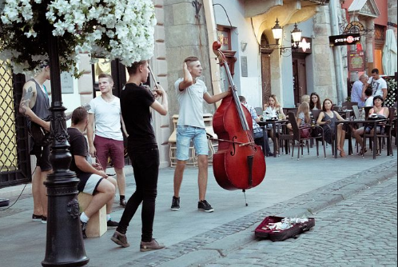
The performers appear to be in their early twenties. They appear to be performing in the streets. Currently, performers are taking their concerts in open-air areas where many people can be accommodated. The people who are seated look like they belong to different age groups. For instance, some appear to be in their early twenties while others appear to be in their 40s. To ensure that the audience’s attention is captured, the performers must tailor their performance content to fit among the different people in the audience.
Besides, this day might have been one of the public holidays. In most cases, people engage in outdoor performances during public holidays. These performers could have lacked enough finance to rent a hall that could accommodate their audience. They could also be trying to popularize themselves to the public. Most of the people who end up becoming famous in the music industry start from taking their performances in the streets so that they can become known long before they start releasing their hits. Therefore, the street is a good avenue where the performers can go to showcase their talents or skills.
The performers could be having fun with their friends or they could be working with an organization that is carrying out a charity drive. In recent people have been keen on their choice of ways of familiarizing their charity organization. Many people love music and thus, whenever the public gathers around the performers, the sponsoring organizations can communicate to the public about their agenda. Also, the performance could have been promoted by an organization so that they could market their products. It is also a common practice by many restaurants and bars to hold performances on the first day of business so that they can attract many customers (Lathrop 161). By looking at the background keenly, it could be asserted this was a new restaurant or bar that was opening and they had to catch the attention of many people as possible.
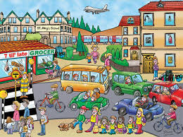
Society has been evolving over the past. There has been invented various means of transport which have enabled people from different social levels to move from one point to another. For instance, there are personal cars and public service vehicles. Personal cars are owned by individuals and they use to move from one point to another. On the other hand, public service vehicles are used to transport any person who might be traveling from one point to another. Others can travel using bicycles. Additionally, other people travel by air. There have been developed high carrying capacity aircraft which fly for long distances (Unruh 120). People travel from one state to another or from one continent to another by air. These different types of transport have led to globalization making the world to be turned into one big society since people can move from one place to another with ease.
Some places are designated for pedestrians. These auto-free zones are only meant for those who are walking to ensure their safety. Some other zones are marked in black and white colors. These zones are referred to as zebra crossing and are meant for pedestrians who might be crossing the busy roads. These areas are fitted with some other road signs which communicate differently. There are traffic lights that guide the pedestrians as well as the motorists on the road. All these signs are meant to ensure safety inroads. For example, school children in most cases cross in Zebra cross zones since some roads carry heavy traffic.
Urbanization has happened like never before. Due to the changing economy, people have been moving from rural areas into urban centers so that they can find employment. The urban areas are filled with many job opportunities and this is the reason why many people have resulted to migrate from rural areas into urban centers around the globe. Urbanization has led to the deterioration of the environment due to the green-house gases which are being emitted by cars (Unruh 131). Cars are powered by oil upon which once burnt gives-off inert gases which ends up destroying the environment. One of the ways through which the community has been countering the effect brought by the inert gases emitted in the air is through planting trees in the cities. Plants consume carbon dioxide which is produced by the vehicles hence reducing the carbon dioxide footprint that is realized in the towns.

Works Cited
Lathrop, Tad, and Jim Pettigrew. This Business of Global Music Marketing. New York, NY: Billboard Books, 2007. Print.
Unruh, Jon D, Maarten S. Krol, and Nurit Kliot. Environmental Change and Its Implications for Population Migration. Dordrecht: Kluwer Academic Publishers, 2004. Internet resource.

